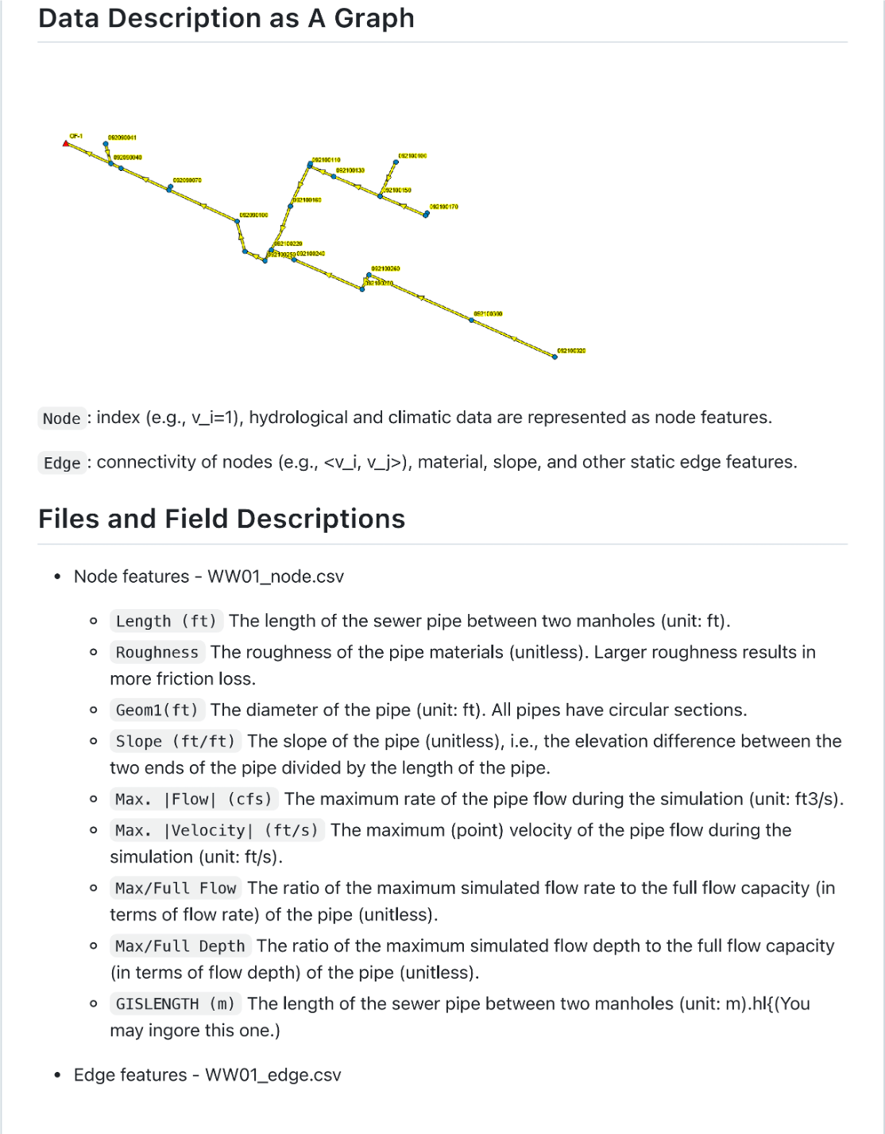

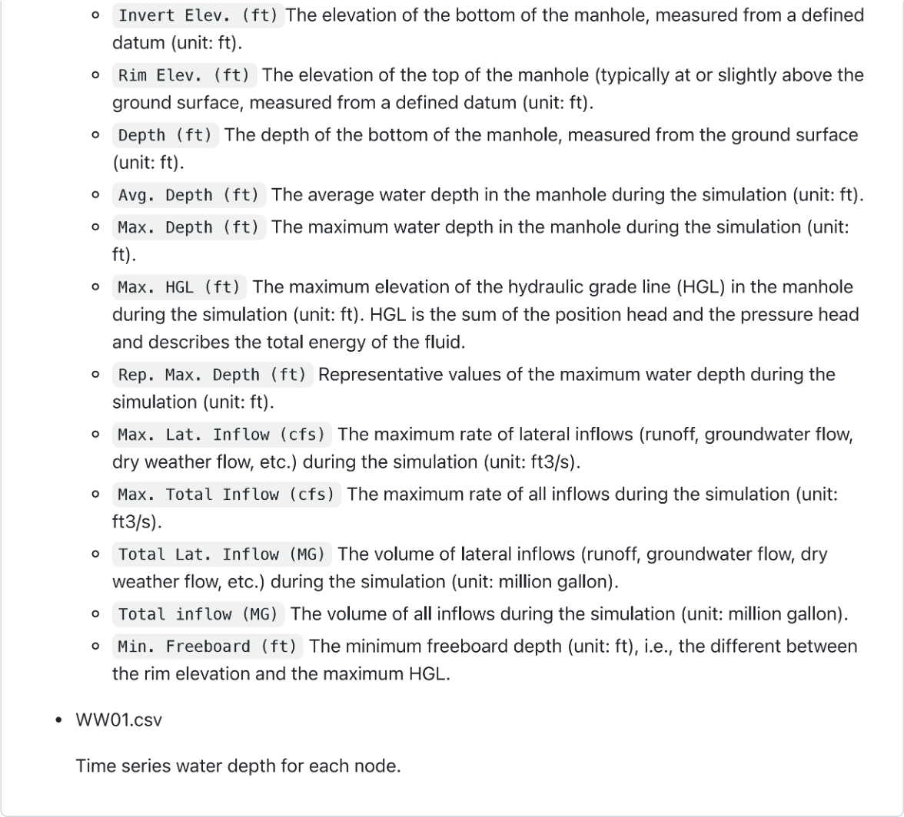

Each node is a junction of a wastewater system and each edge is a pipe of a wastewater system.

WW01_v3 folder

* WW01_v3.xls

Water depth for each node during a certain time

* Flow_rate.csv

The inflow rate for each node during a certain time